Elijah Chau & Ethan Ju
Oscillator Lab

1. (2 points) Write a brief introduction describing the system you are studying and the goals of the experiment.
2. (2 points) Include a photograph or sketch of your team’s experimental setup. Label the relevant components.
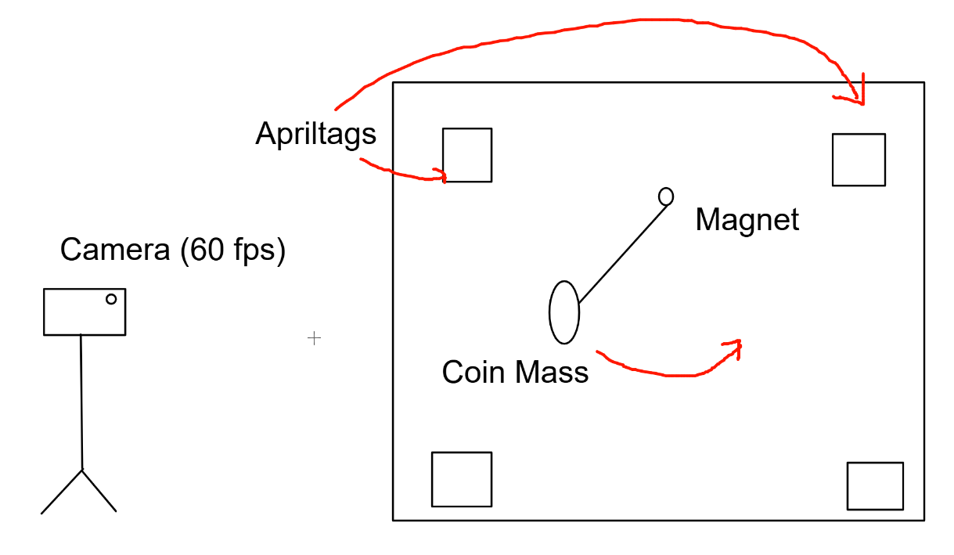
3. (3 points) Describe the experimental procedure in your own words.
4. (3 point) Please answer the following questions:
- What are the units of the angle, θ?
  - Radians
- What are the units of the angular velocity, ˙θ = ω(t)?
  - Radians / second
- What are the units of the angular acceleration, ¨θ = ˙ω(t) = α(t)?
  - Radians / second^2
- What is the natural frequency of the system ωn, in terms of g and l?
  - ωn = sqrt(g / l)
- What are the units of the natural frequency?
  - Radians / second
5. (2 points) Given the length, l, of the pendulum in your experimental setup, predict its natural frequency, ωn.
  - The length of our pendulum was 0.255 m, so we predict our natural frequency to be ωn = sqrt(9.81 m/s^2 / 0.255m) = 6.202 Hz, or 38.968 rad/s.
6. (2 points) It is likely that the angle measurements generated by the data processing software are off by a fixed constant, because either the ArUco marker is not oriented perfectly, or the camera is tilted a bit:
θmeasured = θactual + θoffset (19.14)
Using any method you choose, estimate the offset, and compute a corrected version of the pendulum angle.
• For this deliverable, explain your angle correction method.
7. (2 points) Plot the corrected angle, θ(t), and the angular velocity, ω(t), of the pendulum as functions of time.
8. (2 points) Plot your measured data in the phase plane, (θ(t), ω(t)).
• Use the code to plot only a few seconds of data so that the plot does not become too crowded.
• Indicate the time span of your plot.
• Note that you should be plotting the corrected angle (not just the raw measured angle).
9. (3 points) Use the plot of θ(t) to estimate the natural frequency, ωn, and damping ratio, ζ, of the system.
• Include your derivation process in the lab report.
• Report your values in a table (don’t forget to include units!)
• We have provided some code, fit_oscillator_data, to help check your analysis.
10. (3 points) Compare your predicted and estimated values for the natural frequency, ωn. Do the values match
reasonably well? If they don’t, provide an explanation for the discrepancy (do not say measurement error!).
11. (3 points) Let’s analyze the damping regime of the system:
- Is the pendulum overdamped, underdamped, or critically damped?
  - The pendulum is underdamped.
- Explain your reasoning in the following two ways:
– Justify the damping regime you chose using the values of ωn and ζ that you estimated.
– Justify the damping regime you chose with the (qualitative) behavior of θ(t) that you measured.
12. (3 points) As a reminder, the second-order linear ODE for a pendulum has the following form:
¨θ + 2ζωn ˙θ + ω2
nθ = 0 (19.15)
Convert this ODE into a system of two first-order differential equations:
˙θ = . . . , ˙ω = . . . , →
˙θ
˙ω

= A
θ
ω

(19.16)
What are the elements of the matrix A? Show your work.
Lab 2: Simple Harmonic Motion 6
13. (3 points) Use your values of ωn and ζ to find the trace and determinant of A:
• What are the units of the trace and determinant?
• Use the trace and determinant to classify the phase portrait of A.
• Is this classification consistent with the phase portrait that you generated from the data?
14. (3 points) Use your values of ωn and ζ to find the eigenvalues of A:
• What are the damped frequency, ωd, and exponential decay rate, σ, of the system?
• Are these values consistent with the oscillation frequency and decay rate observed in the plot of θ(t)?
• Plot the complex exponential eigenvalues, λ± = −σ ± iωd on the complex plane.
15. (3 points) Use your estimated values of ωn and ζ to simulate the system numerically:
• See the appendix for resources on how to do this.
• Create a plot that overlays the numerical solution on top of your experimental data (vs. time).
• Note that this should be a new plot, submitted in addition to the first plot of θ(t) vs. t.
• How well does the model fit the data? Discuss any differences that you observe.
16. (3 points) Use your estimated values of ωn and ζ to generate a phase portrait for the system.
• Use at least 3 different initial conditions when drawing trajectories on the phase plane.
• On the same axes, underlay a quiver plot of the vector field describing the ODE:
˙x =
˙θ
˙ω

=
ω
−ω2
nθ − 2ζωnω

(19.17)
You may need to scale the vector field by a constant to reduce clutter.
• Compare this phase portrait to the trajectory of your experimental data on the phase plane.
– How are the two plots similar/different?
– If the two plots are significantly different, what do you think is the source of this difference?
17. (3 points) Let’s define a new independent variable, ˜t, which is the time scaled by the natural frequency, ωn:
˜t = ωnt (19.18)
Show that our ODE can be rewritten as follows:
d2θ(˜t)
d˜t2 + 2ζ dθ(˜t)
d˜t + θ(˜t) = 0 (19.19)
The chain rule of derivatives will come in handy here:
du(t)
dt = du(˜t)
d˜t
d˜t
dt = du(˜t)
d˜t ωn, → d2u(t)
dt2 = d2u(˜t)
d˜t2 ω2
n (19.20)
What does this result tell us about how the natural frequency, ωn, affects the system behavior?
Finally, we ask that you edit your work into a cohesive lab report following the format and submission guidelines
stated previously. This is the style portion of the rubric, which is worth 5 points (10%) of your lab report grade.

